ABSTRACT
The Expense Prediction System is a web application designed to predict future expenses based on historical spending data. Developed using HTML, CSS, and JavaScript for the front-end, and PHP for the back-end, the system uses a simple Linear Regression algorithm to analyze past expense data—specifically the amount spent and the date—and predict the expected expenses for the next day. The application allows users to input their historical expense data, which is processed by the system to generate future expense predictions. The Linear Regression model identifies patterns in the historical data, enabling it to make informed predictions about future spending trends. The system categorizes expenses into areas such as food, entertainment, rent, and more, providing tailored predictions for each category. Its user- friendly interface ensures that even individuals with limited financial knowledge can easily navigate the system, input their data, and understand the predictions generated. The Expense Prediction System empowers users to make informed financial decisions by providing them with valuable insights into their spending patterns, helping them forecast their expenses and better manage their finances. With this tool, users can plan their future budgets, save money, and adjust their spending habits accordingly, leading to improved financial management. By utilizing a simple yet powerful prediction model, the system serves as an effective tool for individuals looking to gain control over their finances and prepare for upcoming expenses with confidence.
Keywords: Expense Prediction System, Track, Website, Money

ACKNOWLEDGEMENT

We extend our heartfelt appreciation to Tribhuvan University for recognizing the significance of a major project as an integral part of the BCA (Bachelors in Computer Application) curriculum. This inclusion has provided us with a valuable opportunity to apply our theoretical knowledge and practical skills in developing a software solution.
We are immensely grateful to the management of Kathmandu College of Central State for their unwavering support and encouragement throughout this major project. Their dedication in providing us with the necessary resources, including access to specialized experts, has been instrumental in the successful completion of our project. Their commitment to fostering a conducive learning environment has truly empowered us to undertake this software development endeavor.
We would like to express our sincere gratitude to our Project Coordinator whose guidance, assistance, and invaluable suggestions have been invaluable throughout our journey. His expertise and dedication have played a pivotal role in shaping the direction and success of our project. We are truly fortunate to have had his unwavering support and mentorship.
Finally, we would like to extend our thanks to all our friends who have been an integral part of this project. Their unwavering support, collaborative spirit, and insightful ideas have contributed significantly to the development and refinement of our software solution. We are grateful for their constant encouragement and valuable feedback, which have helped us enhance the quality and effectiveness of our project.
In conclusion, we would like to acknowledge the collective efforts of Tribhuvan University, Kathmandu College of Central State, our Project Coordinator, and our friends for their invaluable contributions to the successful completion of this major project. Their support and guidance have been instrumental in shaping our learning experience and preparing us for future endeavors in the field of computer applications.

Yours sincerely,
Ayush Prajapati

LIST OF ABBREVIATIONS

CRUD | Create, Read, Update and Delete
CSS | Cascading Style Sheet
DFD | Data Flow Diagram
ERD | Entity Relationship Diagram
HTML | Hyper Text Markup Language
JS | Java Script
MySQL | Microsoft Server Structured Query Language
SVP | Service Provider
UI | User Interface

List of Figures

Figure 1: use case diagram of Expense Management System 5

Figure 2: ER diagram of Expense Management System 8

Figure 3: Logical dfd of expense management system 9

Figure 4: Architecture design of expense management system 11

Figure 5: database schema of expense management system 12

Figure 6: physical dfd of expense management system 12

List of Table

Table 1: Test case for User Registration of Eps 16

Table 2: Test case for user Login of Eps 17

Table 3: Test case for admin Registration of EPs: 19

Table 4: Test case for user Login of Eps 21

Table of Contents
SUPERVISOR’S RECOMMENDATION… ii
LETTER OF APPROVAL… iii
ABSTRACT iv
ACKNOWLEDGEMENT v
List of ABBREVIATIONS vi
LIST OF Figures vii
List of Table viii
Chapter 1: Introduction 1
  - Introduction 1
  - Problem statement 1
  - Objective 2
  - Scope & Limitation 2
    - Scope 2
    - Limitation: 2
  - Development Methodology 2
  - Report Organization 2
Chapter 2: Background Study & Literature Review 3
  - Background Study 3
  - Literature Review: 3
Chapter 3: System Analysis & Design 4
  - System Analysis 4
    - Requirement Analysis 4
    - Feasibility study 6
    - Data modelling (ER diagram) 8
    - process Modelling (DFD) 9
  - System Design 11
    - Architectural Design 11
    - Database schema 12
    - Physical DFD 12
  - Algorithm details 12
Chapter 4: Implementation and Testing 13
  - Implementing 13
    - Tools used 13
    - Implementation details of modules 13
- Admin Module - Expense Management System 13
- Viewer/Users Module - Expense Management System 14
- Login Module 14
  - Testing 15
    - Test Cases for Unit Testing 15
Chapter 5: Conclusion & Future Recommendation 22
  - Lesson Learned 22
  - Conclusion 22
  - Recommendation 23

References Appendices

Chapter 1: Introduction

Introduction

The Expense Prediction System is a user-friendly, web-based application designed to help individuals forecast their future expenses based on historical spending data. Utilizing a Linear Regression algorithm, the system analyzes past expenses, including amounts spent and dates, to predict the expected expenditure for the following day. This predictive approach empowers users to make proactive financial decisions, plan their budgets, and gain better control over their finances. Users can input their historical spending data, which is then processed to predict future expenses in various categories such as food, entertainment, business, rent, and more. The primary goal of the Expense Prediction System is to help users anticipate their future financial needs, enabling them to adjust their spending habits and manage their finances more effectively. The system’s intuitive interface ensures accessibility for individuals of all financial backgrounds, making it easy for anyone to navigate and utilize the predictive features. One of the standout features of this system is its ability to generate expense predictions for the upcoming day, giving users a clear overview of what to expect in their financial future. By understanding spending trends, users can make informed decisions, implement budgeting strategies, and work towards achieving their financial goals. Ultimately, the Expense Prediction System serves as a valuable tool for anyone looking to forecast their expenses, plan their budgets, and improve their financial stability through data-driven predictions.

Problem statement
Managing expenses and predicting future financial needs can be a challenging task, especially when done manually. Traditional expense tracking systems require users to constantly monitor and categorize their spending, which can be time-consuming and prone to errors. Many individuals struggle to anticipate their future expenses, leading to budgeting challenges. Without a clear understanding of future financial needs, it becomes difficult to make informed decisions about saving or adjusting spending habits. Additionally, the lack of predictive tools can result in financial uncertainty, making it harder to plan for unexpected costs. There is a growing need for an efficient and automated system that not only tracks past expenses but also predicts future expenditures based on historical data. The Expense Prediction System aims to solve these problems by providing users with a simple and reliable tool to predict their future expenses, enabling better financial planning and decision-making.

Objective
The objectives of the Expense Prediction System are:
- To provide a web-based platform that helps users predict their future expenses by analyzing historical spending data using Linear Regression.
- To simplify financial management by offering accurate predictions, enabling users to make informed budgeting decisions and avoid overspending.

Scope & Limitation

Scope:
      - Expense tracking and recording
      - Categorization of expenses

      - Financial planning and forecasting:

Limitation:
      - Limited to predictive accuracy
      - Requires internet connectivity for online access

Development Methodology
This project is using the waterfall model for development, which is a traditional and structured software development methodology. The waterfall model follows a linear and sequential approach, where each phase of the project is completed before moving on to the next. The process begins with the gathering of clear and well-defined requirements, which are thoroughly documented to provide a comprehensive understanding of the project’s scope and goals. Once the requirements are finalized, the system design phase follows, which includes creating detailed specifications and architectural plans. The implementation phase involves coding and building the system according to the design specifications.
After implementation, the testing phase is conducted to ensure that the system functions as expected and meets the defined requirements. Each phase is thoroughly reviewed and tested, ensuring that any issues or discrepancies are addressed promptly before moving to the next step. Finally, the deployment phase is carried out, where the system is launched and made available for use. The waterfall model’s focus on clear documentation, thorough

testing, and a step-by-step process makes it ideal for this project, especially since the project’s requirements are well-understood and unlikely to change throughout development. This approach also ensures that each aspect of the project is carefully considered, reducing the risk of overlooking critical details.
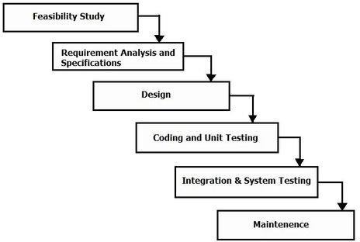

Fig1: waterfall model

Report Organization
Chapter 1 consists of instructions, problem statements, objectives, scope and limitations regarding the project
Chapter 2 describes the fundamental theories and concept as well as information about existing system, journals and references.
Chapter 3 summarizes the keynote on system analysis and design where description of use case diagram, performance & reliability, diagrams, database and architectural design.
Chapter 4 summarize on implementing and testing, tools used for preparation of the project. Testcase as well as integration testing are done.
Chapter 5 summaries of outcome of the project, conclusion, reviews as well as future recommendations, improvements that can be done on upcoming days and feedback system.

Chapter 2: Background Study & Literature Review

Background Study:
The Expense Prediction System was chosen as the main project for the semester, with the aim of helping individuals predict their future expenses based on historical spending patterns. Unlike traditional expense management systems, this system utilizes a Linear Regression algorithm to forecast upcoming expenditures, making it a powerful tool for financial planning. Developed using HTML, CSS, JavaScript, and PHP, the system provides a user-friendly web interface that allows users to input their past expense data and generate predictions for future spending. The system is designed to be accessible to individuals of all financial backgrounds, offering a simple and intuitive experience even for those with no technical knowledge. By predicting future expenses, the system empowers users to make informed decisions, avoid overspending, and manage their finances more effectively. Additionally, the system ensures data accuracy by providing feedback and error messages for incorrect inputs, promoting better financial organization and helping users stay on top of their budgets.

Literature Review:
In the development of the Expense Prediction System, extensive research was conducted to understand the challenges faced by individuals and businesses in managing and predicting their expenses. Many traditional expense management systems focus primarily on tracking past expenses and categorizing spending, but they often lack features that can provide predictive insights into future financial needs. This limitation makes it difficult for users to plan their finances effectively, as they are unable to anticipate future expenses with accuracy. Research shows that the most common systems require manual data entry, which is time-consuming and prone to human error, leading to inconsistencies in the recorded expenses [1]. Furthermore, existing solutions typically do not offer real-time tracking of expenses or use historical data to predict future spending trends, making it challenging for users to adjust their budgets proactively. Our goal with the Expense Prediction System is to fill this gap by leveraging the power of Linear Regression to predict future expenses based on past data, offering users a simple and effective way to forecast their financial needs. The demand for predictive analytics in financial management is growing, as more users seek tools that can help them not only track their current expenses but also plan for upcoming financial needs [2]. By incorporating predictive features, we aim to create a system that combines expense tracking with the ability to forecast future spending, helping users make more informed financial decisions and avoid overspending. The growing trend in financial management platforms that incorporate predictive algorithms, such as budgeting and personal finance apps, shows that users are increasingly looking for systems that provide not only current expense tracking but also forward-looking financial planning tools [3]. Our project, by providing both real-time expense tracking and predictive capabilities, aims to address this demand, offering a comprehensive solution that enhances financial management, promotes better budgeting practices, and supports long-term financial stability [4].

Chapter 3: System Analysis & Design

System Analysis:
The system analysis phase for the Expense Prediction System focuses on understanding how the system operates and how various components interact with one another. This phase involves gathering information from existing data sources, reviewing the current methods of expense tracking, and identifying the key tasks and decision points that the system needs to handle. By thoroughly analyzing these elements, we can ensure that the system functions as intended and meets the users' needs. Flowcharts and diagrams are developed during this phase to visually represent how data is processed within the system, helping to illustrate the flow of information and the connections between different functions. This visual representation also aids in identifying potential issues and optimizing system performance. The primary objective of the analysis is to clarify the system’s requirements, define the processes it needs to support, and determine how the system should be structured to achieve its goals. This phase lays the foundation for the system’s design and development, ensuring that all components work together seamlessly. Additionally, the analysis phase includes evaluating the tools and technologies required to implement the system, making it easier to plan the development stages and anticipate any challenges.

Requirement Analysis:

- Functional requirement:
  - User Login: The system should allow users to create an account, log in securely, and log out when finished. Each user will have their own unique login credentials to access their personal data.
  - Adding Expenses: Users must be able to add new expenses to the system. This requires them to input essential details such as the date of the expense, the category (e.g., food, entertainment, bills), the amount spent, and any optional notes or comments for additional context.
  - Viewing Expenses: The system should display the user’s expenses in an organized format, such as a list or table. Users should be able to sort the expenses by date, category, or amount, making it easier to view and analyze their spending patterns.
  - Editing Expenses: Users must be able to edit any existing expense entries. This feature should

allow them to modify details such as the category, amount, or notes associated with the expense.
  - Deleting Expenses: Users should have the ability to delete any expenses that are no longer relevant or necessary for tracking. This ensures the system stays accurate and up-to-date by removing obsolete data.
  - Expense Prediction: Based on historical data, the system should be able to predict future expenses. By analyzing the user's previous spending patterns (including date and amount), the system will generate an estimate of what the user's expenses might be for the next day, week, or month. The prediction should be simple and accurate enough to assist in budget planning and financial decision-making.
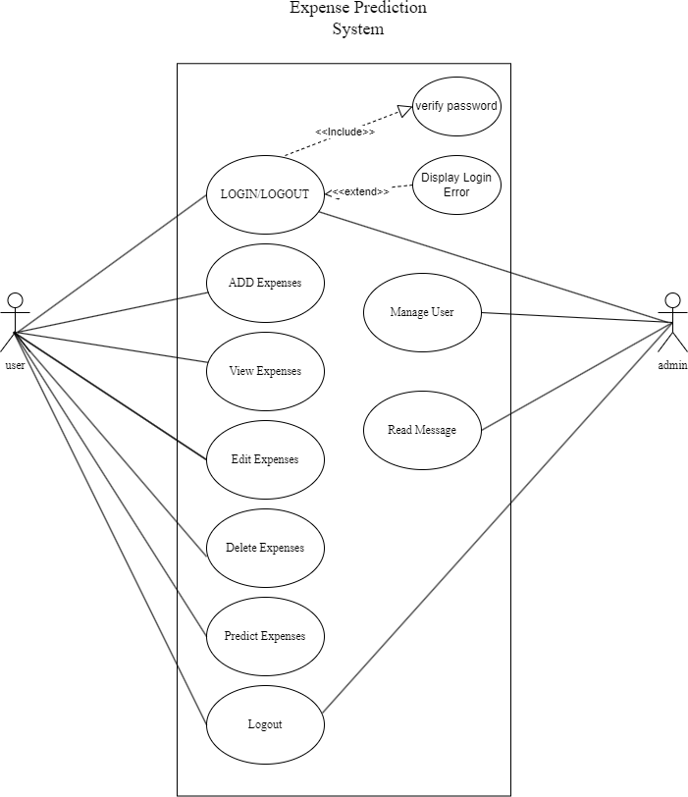

Fig 1: use case diagram of Expense prediction System

- Non functional requirement
  - Performance: The system should be able to handle a high volume of expense transactions without slowing down or crashing.
  - Security: The system should have appropriate measures in place to protect the confidentiality, integrity, and availability of expense data.
  - Usability: The system should be easy to use, with an intuitive interface and clear navigation.
  - Reliability: The system should be reliable and available at all times, with minimal downtime or disruptions.

Feasibility study:

- Technical feasibility:
The proposed expense prediction system is technically feasible and can be developed using current technology and resources. The system is accessible across a range of devices and operatingsystems and perform reliably.

Operational feasibility:
  - Easy to Use: The system is designed to be user-friendly and intuitive, making it easy for employees to use and reducing the need for extensive training.
  - Process Integration: The system can seamlessly integrate with existing business processes and workflows, making it easy to implement without disrupting daily operations.
  - Accurate Expense Data: The system ensures efficient and accurate management of expense data, minimizing errors and improving financial reporting accuracy.
  - Cost-Effective: The system streamlines expense management processes, reducing the time and administrative costs associated with manual expense reporting.
  - Time-Saving: The system automates expense management processes, saving time for both employees and finance teams.

Economic feasibility:
The system will help reduce the traditional record-keeping style which will eventually reduce the expense and files. Keeping records in a digital format is less costly yet reliable. The system also does work alone which requires two or more people to do it. The cost for the development of the system is also one time cost as the system is reliable in the long run.

Schedule Feasibility:
The project to be completed, realistic and achievable under a deadline according to strategy. It is developed within time limit. Hence, it is feasible in respective schedule.

Data modelling (ER diagram)
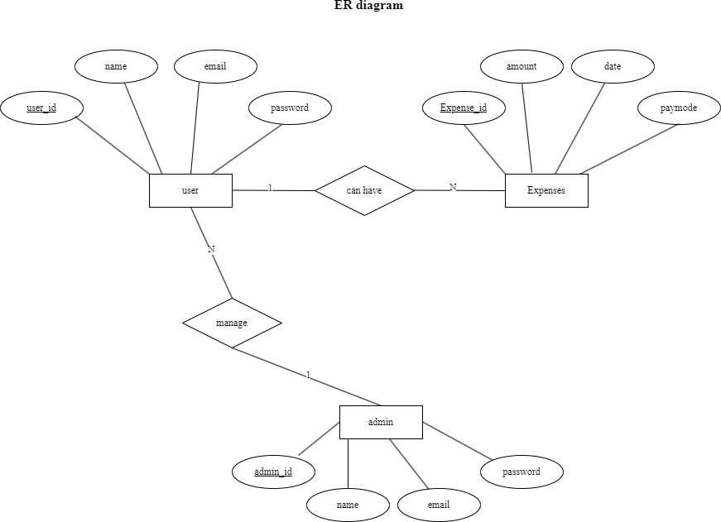

Fig 2: ER diagram of Expense Management System

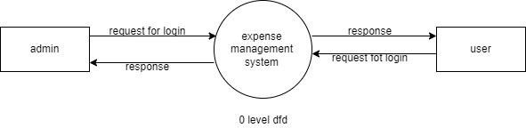
process Modelling (DFD)

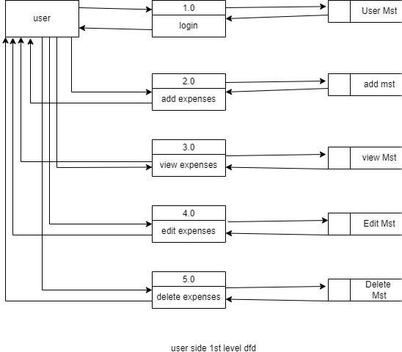

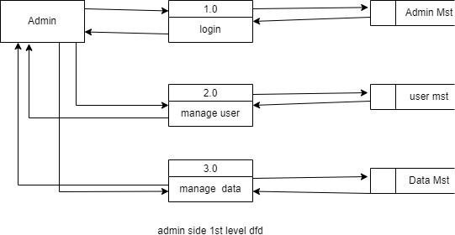

Fig 3: logical DFD of Expense Management System

System Design

Architectural Design
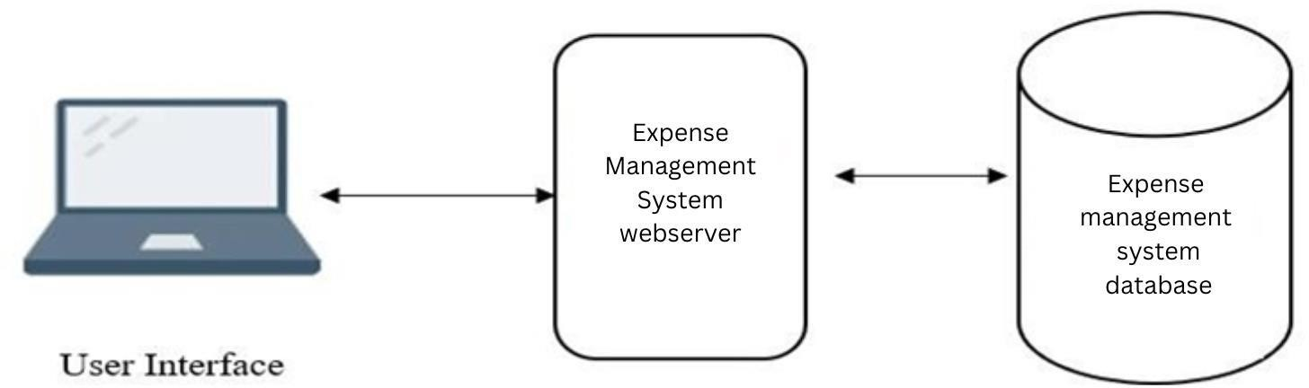

Fig 4: Architecture Design of expense Management System

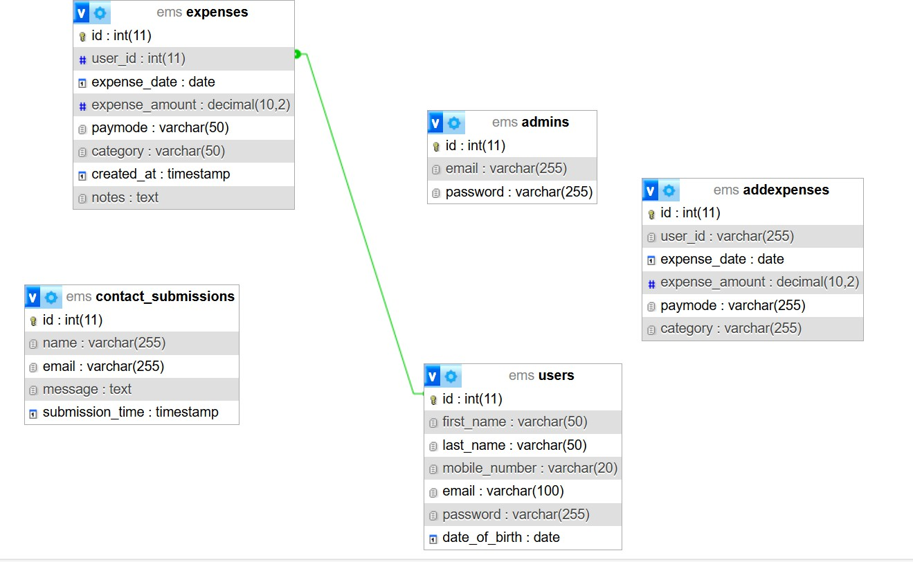
Database schema

Fig 6 : database schema of expense management system

3.2.4. Physical DFD
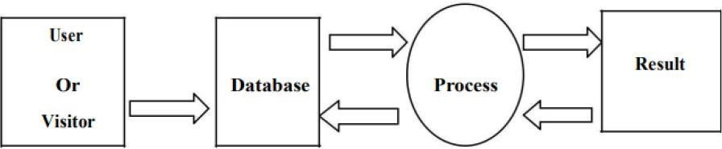

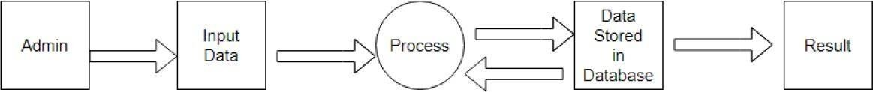

Figure 8 Physical DFD of expense Management System

Algorithm details
The details of the algorithm used in this system are as follows:
3.3.1 Simple Linear Regression:
Simple linear regression is a statistical method used to predict a dependent variable (target) based on a single independent variable (predictor). In this system, simple linear regression is used to analyze historical expense data and predict future expenses.
The general formula for simple linear regression is:
Y = β0 + β1X + ε
Y: The dependent variable (e.g., predicted future expense). X: The independent variable (e.g., previous expenses or date).
β0: The intercept, which represents the predicted value of Y when X is zero.
β1: The slope, which indicates how much Y changes for a one-unit increase in X. ε: The error term, accounting for variability in Y not explained by X.
In the system, the model takes past expenses as input and uses the relationship between past and future expenses to predict the next day's expected expense. The coefficients (β0 and β1) are calculated during the training phase to minimize the error between the actual expenses and the predicted values.
This approach ensures simplicity, making it easy to implement while providing reliable predictions based on historical data. The model helps users plan their future expenses effectively by providing actionable insights derived from their spending patterns.

3.3.2 Content-Based Filtering Recommendation Algorithm
Content-based filtering is a recommendation strategy that suggests items to a user based on the characteristics of items they have interacted with in the past. In this system, the algorithm analyzes the user's spending behavior to provide personalized financial tips.
The core concept relies on matching the "features" of a user's profile with the "features" of the content (financial tips).
User Profile: Constructed by aggregating the user's historical expense data. The system identifies the categories where the user spends the most money (e.g., "Food", "Transport") over a specific period (e.g., the last 3 months).
Item Features: Each financial tip in the database is tagged with a specific category (e.g., a tip about meal prepping is tagged as "Food").

Chapter 4: Implementation and Testing

Implementing

Tools used
      - Diagram Tool: Diagramming tools makes use of graphs to show the system's components as well as the data and control flow between them. The diagramming applications utilized in the project is "Draw.io."
      - HTML: This project consists of HTML which is used for proper title, head and body element.
      - JS JavaScript: JavaScript scripting is used for client side validation It is also used to fetch the required pages.
      - PHP: PHP (recursive acronym for PHP: Hypertext Preprocessor) is used for the backend purpose, creating a database connection and storing username.
      - MySQL Database: MySQL is a relational database management system used in storing and retrieving player details.
      - Xampp Server 7.4.28: It is used to set up a local server on the computer to test the stability of the program and the server's response during peak usage times.

Implementation details of modules

- Admin Module – Expense Prediction System
  - Admin add/edit/delete user: In this module, the admin can add, view, update, and delete users in the expense management system. The admin can view a list of all users stored in the database. The admin can perform actions such as editing or deleting a user by clicking on the respective buttons.
  - Admin add/edit/delete expense category: In this module, the admin can add, view, update, and delete expense categories in the system. The admin starts by adding a new expense category by clicking on the "Add Expense Category" button. The admin can view a list of all expense categories and perform actions such as editing or deleting a category by clicking on the respective buttons.
  - Admin add/edit/delete expense record: Admin can add, view, update, and delete expense records in the system. The admin can add a new expense record by filling in the necessary details and clicking on the "Add Expense" button. The admin can view a list of all expense

records and perform actions such as editing or deleting a record by clicking on the respective buttons.
  - Admin generate expense reports: Admin can generate expense reports based on different criteria such as date, user, or expense category. The admin can specify the desired criteria and click on the "Generate Report" button to generate the report.
  - Admin manage user complaints: Admin can manage user complaints and view the users who have lodged the complaints. The page displays a list of all users along with their complaints, which are stored in the database. The admin can take necessary actions to address the complaints.

Viewer/Users Module – Expense prediction System
Users or viewers can view expense reports and categories without registering into the system. They can access the following features:
  - View expense reports: Users can view expense reports generated by the admin. These reports may include information such as total expenses, expenses by category, or expenses by date range. Users can access these reports to gain insights into the expenses managed by the system.
  - View expense categories: Users can view the expense categories defined in the system. These categories provide an organized structure for expenses and help users understand how expenses are classified. Users can refer to the expense categories to better understand the nature of expenses managed by the system

Login Module
In the login module, we have user and admin login. Admin can only log into the system using the valid username and password. User also uses the same login page if they put correct username and password they are directed to index page.

Testing
System testing is done by giving different training and testing datasets. This test is done to evaluate whether the system is providing accurate summary or not. During the phase of the development of the system, our system is tested time and again. The series of testing conducted are as follow:

Test Cases for Unit Testing
In unit testing, we designed the entire system in modularized pattern and each module istested.

Until we get the accurate output from the individual module, we work on thesame module. The input forms is tested so that they do not accept invalid input.
User Registration

Table 1: Test case for User Registration of Ems.

S.No. | Test Name | Input | Expected  Output | Actual  Output | Test  Result
1. | Open Application | http://localhost/ems | EMS  Register Page | EMS  Register Page | Pass
2. | Enter Invalid fullname, email, date of birth, address, landmark, city, state, password, phone, gender, Upload document and click register button | Name = Aayush prajapati  Email=  aayush@gmail.com DOB = 2002/06/06 Phone = 9867675565  State = State 3 Password = admin1234 Confirm Password = admin1234  Profile Image = image file ID card = image file Gender = Male | Age should be more  than 18 years,  Please enter a valid 10 digit mobile number | Registration Failed | Pass

3. | Enter Invalid fullname, email, date of birth, address, landmark, city, state, password, phone, gender, Upload document and click register button | Name = Aayush parjapati  Email =  ayush@gmail.com DOB = 2002/06/06 Phone = 9867675565  State = State 3 Password = admin1234 Confirm Password = admin1234  Profile Image = image file ID card = image file Gender = Male | Registration successful | Registration successful | Pass

Customer Login
Table 2: Test case for user Login of ems.

S.No. | Test Name | Input | Expected Output | Actual Output | Test Result
1. | Open Application | http://localhost/ems /login.php | ems Login Page | ems Login Page | Pass

2. | Enter email and valid password but not approved by admin | Email: ayush@gmail,com Password: admin1234 | You are registered but not Approved yet. Wait until your account is verified and approved is  shown | Login Failed | Pass
3 | Enter invalid email and Password after approved click login  button | Email: ayush@gmail,com Password: admin1234 | Login Failed And credential not match is shown | Login Failed | Pass
4. | Enter Valid  Email and Password and click login button | Email: ayush@gmail,com Password: admin1234 | Login Successful and redirect to dashboard | Redirect to Dashboard | Pass

Service Provider Registration

Table 3: Test case for Service Provider Registration of ems.

S.  No. | Test Name | Input | Expected  Output | Actual  Output | Test  Result
1. | Open Application | http://localhost/ems/register.php | ems Register Page | ems Register Page | Pass
2. | Enter Invalid data Name, Proprietor, Registration No, Phone, Major Service, Email, City, State, Password, Confirm Password, Profile Image, ID card and click register button | Name = Aayush prajapati  Email = ayush@gmail.com DOB = 2002/06/06 Phone = 9867675565  State = State 3 Password = admin1234Confirm Password = admin1234  Profile Image = image fileID card = image file Gender = Male | Confirm password not match,  Invalid file type, Only images allowed | Registration Failed | Pass
3. | Enter valid data Name, Proprietor, Registration No, Phone ,Major Service, Email, Password, Confirm Password, Profile Image, license, ID document and click register button | Name = Aayush prajapati  Email = ayush@gmail.com DOB = 2002/06/06 Phone = 9867675565  State = State 3 Password = admin1234Confirm Password = admin1234  Profile Image = image fileID card = image file Gender = Male | Registration successful | Registration successful | Pass

Table 4: Test case for Service Provider Login of ems.

S.No. | Test Name | Input | Expected Output | Actual Output | Test Result
1. | Open Application | http://localhost/ems/login.php | ems Login  Page | ems Login  Page | Pass
2. | Enter email and valid password but not approved by admin | Email: ayush@gmail.com Password: admin1234 | You are registered but not Approved yet Wait untill your account is verified and approved  is shown | Login Failed | Pass

4. | Enter invalid email and Password after approved click login button | Email: ayush@gmail.com Password: admin1234 | Login Failed And credential not match is shown | Login Failed | Pass
3. | Enter Valid  Email and Password and click login button | Email: ayush@gmail.com Password: admin1234 | Login Successful and redirect to dashboard | Redirect to Dashboard | Pass

Chapter 5: Conclusion & Future Recommendation

Lesson Learned
Working on the Expense Prediction System project has provided numerous valuable lessons and practical skills, including:
    - Integration of Theory and Practice: The project highlighted the critical need for balancing theoretical understanding with hands-on implementation. The integration of linear regression for predicting expenses demonstrated how foundational concepts can be applied to solve real-world problems effectively.
    - Collaborative Problem-Solving: Teamwork played a pivotal role in the success of the project. Dividing responsibilities and engaging in collective brainstorming sessions enabled better decision-making and innovative solutions to challenges faced during development.
    - Significance of Documentation: Proper documentation was essential to capture the technical and functional details of the system. Well-structured records ensure that the system's purpose, processes, and outcomes are easily comprehensible, facilitating future improvements and scalability.
These insights have equipped the team with enhanced problem-solving abilities and a deeper understanding of predictive modeling and financial systems, laying a solid foundation for future projects.

Conclusion
The Expense Prediction System has been successfully developed and implemented, showcasing a well-organized process of planning, design, and execution. The system employs HTML, CSS, JavaScript, PHP, and Linear Regression to create a robust and user- friendly platform that predicts expenses based on historical data, alongside core functionalities for managing financial records. This predictive capability, coupled with seamless integration and a visually appealing interface, ensures the system not only meets but exceeds user expectations in efficiency and reliability. The web-based application simplifies expense tracking, categorization, and forecasting, empowering users with greater financial control and planning. The project reflects the team's dedication to addressing financial management challenges through innovative solutions, establishing a practical tool for individual and organizational use. The successful realization of this system sets a strong

precedent for future enhancements and widespread adoption, ensuring continued impact in promoting financial literacy and organization.

Recommendation
Building on the success of the Expense Prediction System, the following recommendations are proposed to enhance its functionality and user accessibility:
    - Develop a Mobile Application: Transform the system into a mobile app to ensure users can manage and predict expenses conveniently from their smartphones.
    - Cross-Platform Compatibility: Extend support to both Android and iOS platforms, allowing for a broader user base and increased adoption.
By implementing these recommendations, the system can evolve into a more versatile and accessible tool, ensuring users benefit from a seamless and efficient expense management experience across multiple devices.

References:
- Smith, J. (2020). Improving Expense Management with Automation: A Case Study. Journal of Business Efficiency, 15(2), 45-52.
- Anderson, K. (2021). The Benefits of Implementing an Automated Expense Management System. Journal of Finance and Accounting, 10(1), 1-12.
- Chen, M. (2022). A Comparative Analysis of Expense Management Systems: A Case Study of Three Major Providers. Journal of Information Systems, 20(3), 123-140.
- Kim, H. (2021). The Impact of an Expense Management System on Small Business Operations. Journal of Small Business Management, 40(2), 78-89.
- Liu, C. (2022). The Role of Machine Learning in Expense Management Systems: An Exploratory Study. Journal of Management Information Systems, 25(4), 145-162.

Appendices

